Paper title (Center, Bold, 16pt)

**Rajesh Natarajan1, Prasanna Ranjith2, Kumar Mohan3 (10 pt)**

1Department of Technology, University of Madras, Chennai, India (9 pt)

2Research Laboratory of IT, Indian Institue of Science, Bengaluru, India

3Department of Information Science, MVIT College. Visvesvarya University, Bengaluru, India

|  |  |  |
| --- | --- | --- |
| **Article Info** |  | **ABSTRACT** (10 PT) |
| ***Article history:***  Received month dd, yyyy  Revised month dd, yyyy  Accepted month dd, yyyy |  | An abstract is often presented separate from the article, so it must be able to stand alone. A well-prepared abstract enables the reader to identify the basic content of a document quickly and accurately, to determine its relevance to their interests, and thus to decide whether to read the document in its entirety. The abstract should be informative and completely self-explanatory, provide a clear statement of the problem, the proposed approach or solution, and point out major findings and conclusions. **The Abstract should be 100 to 200 words in length.** References should be avoided, but if essential, then cite the author(s) and year(s). Standard nomenclature should be used, and non-standard or uncommon abbreviations should be avoided, but if essential they must be defined at their first mention in the abstract itself. No literature should be cited. The keyword list provides the opportunity to add 5 to 7 keywords, used by the indexing and abstracting services, in addition to those already present in the title (9 pt). |
| ***Keywords:***  First keyword  Second keyword  Third keyword  Fourth keyword  Fifth keyword |
| *This is an open access article under the* [*CC BY-SA*](https://creativecommons.org/licenses/by-sa/4.0/) *license.* |
| ***Corresponding Author:***  Rajesh Natarajan  Department of Information Technology  University of Madras  Chennai  India  Email: rajesh@mail.com | | |

1. **INTRODUCTION (10 PT)**

The main text format consists of a flat left-right columns on A4 paper (quarto). The margin text from the left and top are 2.5 cm, right and bottom are 2 cm. The manuscript is written in Microsoft Word, single space, Time New Roman 10 pt, and minimum 6 pages for original research article or review/survey paper, which can be downloaded at the website: <https://www.ijitra.com/index.php/ijitra/author-guidelines>.

The Introduction section should provide: i) a clear background, ii) a clear statement of the problem, iii) the relevant literature on the subject, iv) the proposed approach or solution, and v) the new value of research which it is innovation (within 3-6 paragraphs). It should be understandable to colleagues from a broad range of scientific disciplines. Organization and citation of the bibliography are made Harvard reference style in sign [1], [2] and so on. The text should be divided into sections, each with a separate heading and numbered consecutively [3]. The section or subsection headings should be typed on a separate line, e.g., 1. INTRODUCTION. A full article usually follows a standard structure: **1.** **Introduction, 2. The Comprehensive Theoretical Basis and/or the Proposed Method/Algorithm** *(optional)***, 3. Method,   
4. Results and Discussion, and 5. Conclusion.** The structure is well-known as **IMRaD** style.

Literature review that has been done author used in the section "INTRODUCTION" to explain   
the difference of the manuscript with other papers, that it is innovative, it are used in the section "METHOD" to describe the step of research and used in the section "RESULTS AND DISCUSSION" to support the analysis of the results [2]. If the manuscript was written really have high originality, which proposed a new method or algorithm, the additional section after the "INTRODUCTION" section and before the "METHOD" section can be added to explain briefly the theory and/or the proposed method/algorithm [4].

1. **METHOD (10 PT)**

Explaining research chronological, including research design, research procedure (in the form of algorithms, Pseudocode or other), how to test and data acquisition [5]–[7]. The description of the course of research should be supported references, so the explanation can be accepted scientifically [2], [4]. Figures 1-2 and Table 1 are presented center, as shown below and cited in the manuscript [5], [6]–[8]. Figure 2(a) the Ensemble approach demonstrates consistent results in the trend line format. Figure 2(b) the recall of the recommended algorithm and the estimates of heart disease made by the existing systems are established.

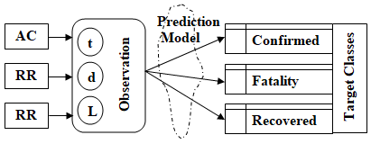

Figure 1. Overview of Prediction Modeling

Table 1. Accuracy report via

5-Fold cross validation

|  |  |  |  |
| --- | --- | --- | --- |
| ML Model | CC | FC | RC |
| DF1 | 81.23 | 77.64 | 85.16 |
| DF2 | 80.32 | 79.3 | 86.54 |
| DF3 | 83.21 | 78.46 | 87.13 |
| DF4 | 82.48 | 76.15 | 88.78 |
| DF5 | 84.36 | 78.37 | 90.13 |
| Error (%) [15, 16] | 2.42 | 5.22 | 1.27 |

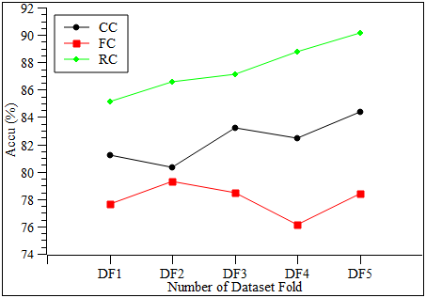

(a)

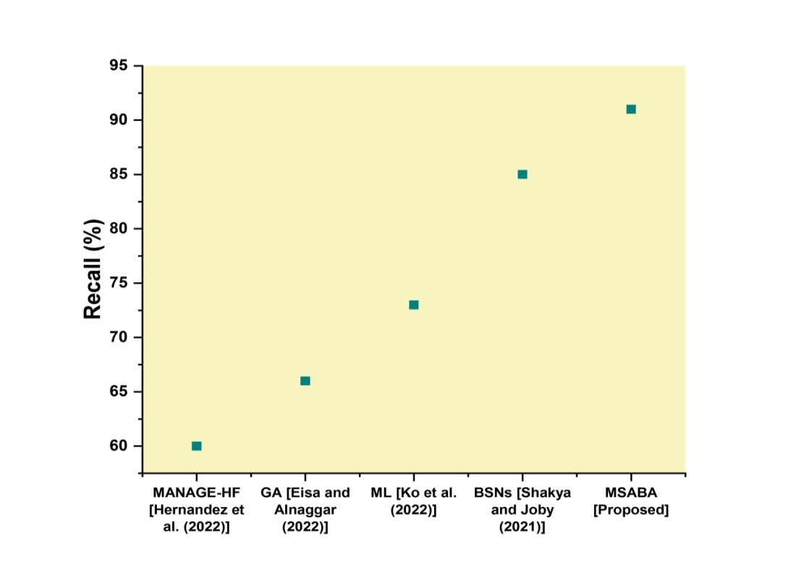

(b)

Figure 2. Comparing simulation results in (a) Comparison of CC, FC and RC and (b) Comparison of Recall

1. **RESULTS AND DISCUSSION (10 PT)**

In this section, it is explained the results of research and at the same time is given   
the comprehensive discussion. Results can be presented in figures, graphs, tables and others that make   
the reader understand easily [4], [5]. The discussion can be made in several sub-sections.

**3.1. Sub section 1**

Equations should be placed at the center of the line and provided consecutively with equation numbers in parentheses flushed to the right margin, as in (1). The use of Microsoft Equation Editor or MathType is preferred.

$Range\left(A,B\right)=\sqrt{\sum_{j=1}^{m}{{(A_{j}-B_{j})}^{2}}}$ (1)

All symbols that have been used in the equations should be defined in the following text.

**3.2. Sub section 2**

Proper citation of other works should be made to avoid plagiarism. When referring to a reference item, please use the reference number as in [6] or [7] for multiple references. Each item in the references section should be typed using 9 pt font size [2]–[5].

3.2.1. Subsub section 1

yy

3.2.2. Subsub section 2

zz

1. **CONCLUSION (10 PT)**

The main conclusions of the experimental work should be presented. The contribution of the work to the scientific community and its economic implications should be emphasized.

**ACKNOWLEDGEMENTS (10 PT)**

Author thanks ... . In most cases, sponsor and financial support acknowledgments.

**FUNDING INFORMATION (10 PT)**

The authors should acknowledge the funders of this manuscript and provide all necessary funding information.

**REFERENCES (10 PT)**

Suggested to use Harvard reference style, size of the text is 9. The template will number citations consecutively within brackets [1]. The sentence punctuation follows the bracket [2]. Refer simply to the reference number, as in [3]—do not use “Ref. [3]” or “reference [3]” except at the beginning of a sentence: “Ref-erence [3] was the first...”

Number footnotes separately in superscripts. Place the actual footnote at the bottom of the column in which it was cited. Do not put footnotes in the reference list. Use let-ters for table footnotes.

Unless there are six authors or more give all authors’ names; do not use “et al.”. Pa-pers that have not been published, even if they have been submitted for publication, should be cited as “unpublished”. Papers that have been accepted for publication should be cited as “in press”. Capitalize each word in a paper title, except for function words and element symbols.

For papers published in translation journals, please give the English citation first, followed by the original foreign-language citation [4]-[9].

For example, [1] is for a journal paper, [2] is for a conference proceeding, [3] is for transactions, [4] is for a book, [5] is article or chapter in an edited book, [6] is for a thesis, [7] is for article in proceedings, [8] is for article from internet, [9] is for a patent.

**REFERENCES**

[1] V, K., Savita Chaudhary and Radhika D (2022) “Feature Extraction in Music information retrival using Machine Learning Algorithms”, *International Journal of Data Informatics and Intelligent Computing*, 1(1), pp. 1–10. doi: 10.5281/zenodo.7093881.

[2] Hu, T. and Desai, J.P. (2004) Soft-Tissue Material Properties under Large Deformation: Strain Rate Effect. *Proceedings of the 26th Annual International Conference of the IEEE EMBS*, San Francisco, 1-5 September 2004, 2758-2761.

[3] Ortega, R., Loria, A. and Kelly, R. (1995) A Semiglobally Stable Output Feedback PI2D Regulator for Robot Manipulators. *IEEE Transactions on Automatic Control*, 40, 1432-1436. http://dx.doi.org/10.1109/9.402235

[4] Wit, E. and McClure, J. (2004) Statistics for Microarrays: Design, Analysis, and Infer-ence. 5th Edition, John Wiley & Sons Ltd., Chichester.

[5] Prasad, A.S. (1982) Clinical and Biochemical Spectrum of Zinc Deficiency in Human Subjects. In: Prasad, A.S., Ed., *Clinical, Biochemical and Nutritional Aspects of Trace El-ements*, Alan R. Liss, Inc., New York, 5-15.

[6] Giambastiani, B.M.S. (2007) Evoluzione Idrologica ed Idrogeologica Della Pineta di san Vitale (Ravenna). Ph.D. Thesis, Bologna University, Bologna.

[7] Wu, J.K. (1994) Two Problems of Computer Mechanics Program System. *Proceedings of Finite Element Analysis and CAD*, Peking University Press, Beijing, 9-15.

[8] Honeycutt, L. (1998) Communication and Design Course. http://dcr.rpi.edu/commdesign/class1.html

[9] Wright and Wright, W. (1906) Flying-Machine. US Patent No. 821393.

**BIOGRAPHIES OF AUTHORS (10 PT)**

**The recommended number of authors is at least 2. One of them as a corresponding author.**

*Please attach clear photo (3x4 cm) and vita. Example of biographies of authors (9 pt):*

|  |  |
| --- | --- |
| D:\Rajesh Jobs\rajesh photo.jpg | **Rajesh Natarajan**     received the bachelore degree in computer science from Bangalore University, Karnataka, Bangalore, in 2005 and the Master degree in Computer Application from Thruvalluvar University, Tamil Nadu, Chennai, in 2008 and the Doctoral in Computer science from Madras University, Tamil Nadu, Chennai, in 2014. He is currently working as a Lecturer at University of Technology and Applied Sciences-Shinas, Sultanate of Oman. His research interest includes data mining, machine learning, big data analytics, blockchain technology, and Data Privacy and Security. He has published articles in the National and International Indexed journals, including SCI, WoS, SCOPUS. He can be contacted at email: rajesh@mail.com. |
|  | **Prasanna Ranjith**     Received a B.Sc., (Computer Science) M.Sc., (Computer Science) and M.Phil., (Computer Science) from the Bharathidasan University of India. Immediately after completion of my Post Graduation, joined as a Lecturer in the Department of computer science in Trichy, during the period June 1997 to June 1999. From 1999 to 2006 served as Lecturer, Coordinator of MCA. Published many papers in various nationa, international conferences and Journals. Has authored book and chapters in Information Technlogy discipline. Study Centre administrating contact classes for students studying under the Open University. In addition, he is a reviewer for leading optical journals such as Optics Express, Optics Letters, Journal of Lightwave Technology and IEEE Photonics Journal. He can be contacted at email: prasanna@aaa.edu.in. |
|  | **Kumar Mohan V**     Resaerch Scholar, SIRMVIT, Bengaluru, Visveshwaraya Techological University, India, Received BE (computer Science and engineering) from Visveshwaraya Techological University, India, MTech (computer Science and engineering) from Visveshwaraya Techological University,India. after completion of his Post Graduation joined as Assiatant Professor in the department of CSE at Vidyavardhaka college of Engineering, India. Currently Working as Assiatant Professor in Department of ISE, M S Ramaiah Institute if Technology, India. Published many papers in various national, international conferences and Journals and Certified iOS Developer. He can be contacted at email: kumar@bbb.edu.in. |